**GROUP PROJECT, GROUP 3**

**DATE: 7 February 2019**

TIME: **11:00 – 12:30**

**12:30 – 12:45 (Chris tutor meeting)**

***12:45 – 13:15 (lunch)***

**13:15 – 15:00**

**ATTENDEES** Tom Gibbs, Henry Crofts

**LOCATION:** *COMMON ROOM*

**Minute Taker: Tom Gibbs**

**Overall aims of the current sprint *(Detailed tasks, user stories and time allocations are tracked on JIRA)***

* Work towards final functionality of game manager
* Work towards final functionality of water level manager
* Work towards final functionality of UI manager
* Begin work/design of tutorial level

**Meeting minutes:**

Both members present.

Team had received response from Chris to say he will help with structuring game manager and event manager as soon as he is available.

Team began by addressing the remaining defined tasks in the sprint.

Team assigned remaining time with the JIRA ‘reserved time’ breaking tasks down to address next high priority issues (after the highest priorities of game/event managers):

* UI manager sprite swapping
* Inconsistent deck interactable behaviours

*JIRA board updated with times and specific tasks (as well as tasks below) to reflect the changes made to the reserve task to address the above issues.*

Team began rectifying inconsistent behaviours that were displayed on first pick-up of some specific ship hold items (wood and barrel). Team were able to make the behaviour reliable by amending methods in the playercontroller script.

Team then met with Chris.

*Please see meeting minutes: ‘2019.02.07 – Tutor meeting – Chris, manager class’ for specific details.*

After meeting with Chris, team discussed the revised approach with the help of a whiteboard for visual aid – to ensure both members shared the same understanding.

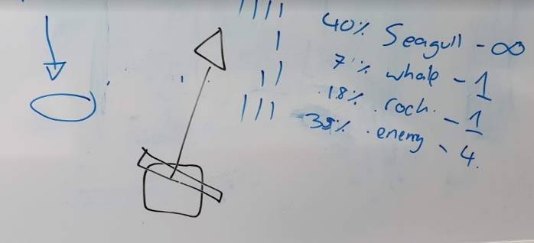

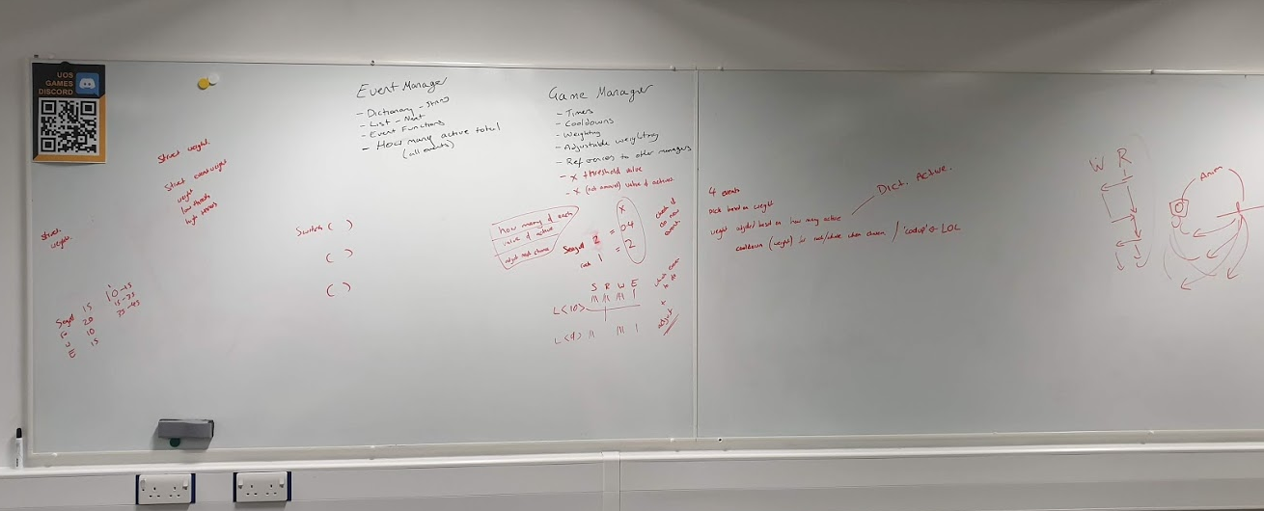

Brief overview:

* Game manager and event manager to be condensed into single event manager class.
* Structs to be used to script each event spawner and dynamically adjust weighting.
* Dictionary and list method of activating/deactivating events to remain as previously included.

Team are confident that both members have the same expectation of work to complete this task. Team used the remainder of the jam implementing the event manager class.

Team made progress, though were unable to fully complete this before having to leave the jam.

Team agree that because the success of this task is fundamental to the game as a whole it should not be completed remotely and the team should hold a further jam this week.

Meeting ended.

Next jam scheduled for Friday 08/02/2019 @ 10:00.

**Tasks for the current week:**

**Tom (12 Hours):**

* **To be completed as part of studio jam, Ensure Event Manager Works Correctly (2h)**

Ensure that the event manager handles the Dictionary correctly holding which events are currently active and removing them correctly from the Dictionary.

* **To be completed as part of studio jam, Ensure Water Level Manager Works Correctly (2h)**

Team should work together to ensure that the water level manager works correctly ending the level when the water level is too high, also raising and lowering the water as required.

* **To be completed as part of studio jam, Ensure UI Manager Works Correctly (2h)**

As a team check that the UI manager works correctly showing the correct events. Spend time fixing any issues with linking into the event manager.

* **To be completed as part of studio jam, give each activity a duration property (30m)**

Team members must work together to ensure a shared understanding for the remainder of development.

Completed task should associate a time with completion of each hazard/task. This should be visually represented by the active players UI indicator. All variables must be exposed in the unity editor for rapid future amendments.

* **Reserved task time, will be split task to be allocated during sprint (all 5h 30m assigned specifically)**

Task to be subdivided into specific tasks once highest priority tasks have been completed.

Team believe manager tasks may overrun anticipated assigned times. All remaining time will be used to address remaining priority issues.

**Reserved task time broken into (tasks also specified within JIRA sprint):**

* **To be completed as part of a studio-jam, review, amend and implement event manager (2h 30m)**
  + Team have found implementation of this manager and it’s interaction with existing managers troublesome. Task used as extension to existing task to continue work on manager.
* **To be completed as part of a studio-jam, bug fix deck interactable behaviour (30m)**
  + Issue identified when items are withdrawn from the ship hold. Team must review script to ensure wood item and cannonball item are interactable on first retrieval.
* **To be completed as part of a studio-jam, bug fix UI manager (1h 30m)**
  + Ensure that managers functionality to select the next available UI image is robust and that sprites are applied to corresponding UI images as dictated by the event manager’s selected event.
* **To be completed as a team, seek tutor advice to restructure event manager (30m)**
  + Request meeting with programming lecturer to discuss current implementation and logic of event manager.
* **To be completed as part of a studio-jam, use tutor advice to restructure event manager (1h)**
  + Using feedback from programming tutor meeting, amend existing event manager implementation to allow for dynamic weighting of events.

**Henry (12 Hours):**

* **To be completed as part of studio jam, Ensure Event Manager Works Correctly (2h)**

Ensure that the event manager handles the Dictionary correctly holding which events are currently active and removing them correctly from the Dictionary.

* **To be completed as part of studio jam, Ensure Water Level Manager Works Correctly (2h)**

Team should work together to ensure that the water level manager works correctly ending the level when the water level is too high, also raising and lowering the water as required.

* **To be completed as part of studio jam, Ensure UI Manager Works Correctly (2h)**

As a team check that the UI manager works correctly showing the correct events. Spend time fixing any issues with linking into the event manager.

* **To be completed as part of studio jam, give each activity a duration property (30m)**

Team members must work together to ensure a shared understanding for the remainder of development.

Completed task should associate a time with completion of each hazard/task. This should be visually represented by the active players UI indicator. All variables must be exposed in the unity editor for rapid future amendments.

* **Reserved task time, will be split task to be allocated during sprint (all 5h 30m assigned specifically)**

Task to be subdivided into specific tasks once highest priority tasks have been completed.

Team believe manager tasks may overrun anticipated assigned times. All remaining time will be used to address remaining priority issues.

**Reserved task time broken into (tasks also specified within JIRA sprint):**

* **To be completed as part of a studio-jam, review, amend and implement event manager (2h 30m)**
  + Team have found implementation of this manager and it’s interaction with existing managers troublesome. Task used as extension to existing task to continue work on manager.
* **To be completed as part of a studio-jam, bug fix deck interactable behaviour (30m)**
  + Issue identified when items are withdrawn from the ship hold. Team must review script to ensure wood item and cannonball item are interactable on first retrieval.
* **To be completed as part of a studio-jam, bug fix UI manager (1h 30m)**
  + Ensure that managers functionality to select the next available UI image is robust and that sprites are applied to corresponding UI images as dictated by the event manager’s selected event.
* **To be completed as a team, seek tutor advice to restructure event manager (30m)**
  + Request meeting with programming lecturer to discuss current implementation and logic of event manager.
* **To be completed as part of a studio-jam, use tutor advice to restructure event manager (1h)**
  + Using feedback from programming tutor meeting, amend existing event manager implementation to allow for dynamic weighting of events.

***Explanation of Task Split on JIRA.***

1. Select the group project from the dropdown menu.
2. Once the project is selected proceed to the backlog where you can see the current sprint and all issues in the backlog.
3. Right click on the issue that has been assigned for contingency in this case the task L6G3–260 and L6G3–261 both named *“To be completed as part of a studio jam, depending on the situation of the project once all other tasks have been completed. As a team assign new tasks and split this task up accordingly”*
4. From the dropdown menu that appears, select “*split issue”* this will then present you with another menu where you can change the task into other tasks without adjusting the scope of the sprint. (provided the number of hours remains the same).

